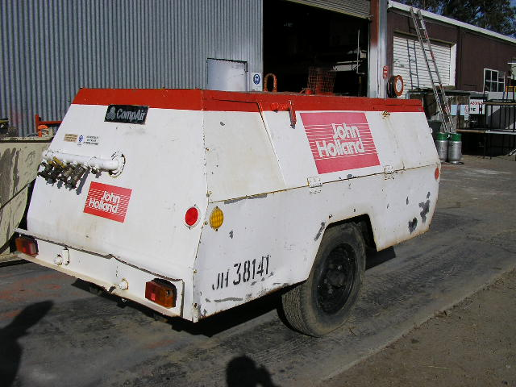 | Hazard Information Sheet
  Equipment: | Air Compressors
 | Equip Type: | Diesel
 | Generic Description or  Specific Make / Model: | Air Compressors
 | Type: | Diesel
 | Other Details

Operator Requirements: | Operators must be trained and competent to use this equipment safely.
Purpose For Which This Equip Is Designed: | An air compressor suitable for powering a wide range of air tools and equipment

Hazards & Risks:
Control Measures:
Crushing (Squashing):  Equip fishtailing and rolling over if towed too fast esp. around corners | When being towed, driver to tow machine relative to road condition and never exceed 80km/h
High Pressure:  Burst air hose | Operator to ensure no damage to air hoses and fittings before use and ensure hoses are not positioned where they are likely to get damaged from falling objects
Possible injury from compressed air directed on skin may cause air bubbles in blood stream | Operator awareness - not to direct compressed air at self or other persons
Possible injury from sudden unexpected compressed air blast when disconnecting tools or hose | Operator to shut off air at compressed air source and release air from tool before disconnecting

Disclaimer: In fulfilment of its statutory obligations, (ARS) & John Holland has taken what it considers to be all reasonable precautions and exercised due diligence to ensure that it has provided all relevant information on the safe use of the plant. However, except as required by law and only to the extent so required, (ARS) & John Holland does not make any representation, warranty or undertaking, express or implied, as to, or accept any responsibility or liability for, the accuracy or completeness of, or any errors in or omissions from, this Hazard Information Sheet. Except as required by law and only to the extent so required, neither (ARS) & John Holland nor any of its respective directors, officers, agents, or employees shall in any way be liable directly or indirectly to any person or body for any loss or damages, costs or expenses whatever arising out of or in connection with the information contained in this Hazard Information Sheet. | Date: 19/06/06
Equipment: | Air Compressors

Hazards & Risks: | Control Measures:
Striking:  Equip rolling away and hitting bystanders etc | Operator to apply hand brake and chock wheel as appropriate.  When towing always connect safety chains
Improperly connected air hose connections can separate and whip causing serious injury | Before use, operator to ensure all air hose connections are locked in place with safety clips
Entanglement:  Becoming entangled in moving parts | Equip to run with doors closed. Shut engine down if necessary to access engine compartment
Slipping, Tripping & Falling:  Air hoses on ground | Awareness of work site personnel
High Temperature or Fire:  Refuelling: When refuelling, sparks, flames, hot engine can ignite fuel. | Operator is responsible to shut engine down prior to refuelling. Refuel in a well ventilated area. Ensure that there are no naked flames in the area. DO NOT SMOKE. Avoid spilling fuel and collect any fuel run off.
Coming into contact with hot parts. | Keep clear of engine and exhaust outlet.
Noise:  Exposure to noise. | Wear appropriate hearing protection.
Suffocation:  Use in a confined space can cause asphyxiation | Use confined space procedures where applicable.
Exposure to exhaust fumes. | If working in poorly ventilated areas monitor exhaust fumes at regular intervals.

Disclaimer: In fulfilment of its statutory obligations, (ARS) & John Holland has taken what it considers to be all reasonable precautions and exercised due diligence to ensure that it has provided all relevant information on the safe use of the plant. However, except as required by law and only to the extent so required, (ARS) & John Holland does not make any representation, warranty or undertaking, express or implied, as to, or accept any responsibility or liability for, the accuracy or completeness of, or any errors in or omissions from, this Hazard Information Sheet. Except as required by law and only to the extent so required, neither (ARS) & John Holland nor any of its respective directors, officers, agents, or employees shall in any way be liable directly or indirectly to any person or body for any loss or damages, costs or expenses whatever arising out of or in connection with the information contained in this Hazard Information Sheet. | Date: 19/06/06

